15BCE0517

M.S.SANJAY

MACHINE LEARNING

L7+L8

EXPERIMENT 3

K-Nearest Neighbour

Sir, I have written my own code. Here I have explicitly given values for k,number of classes, number of dimensions and the data points and also chosen centroid randomnly for convenience. It can also be got as input from user. The implementation is generalized I.e. doesn’t require any specific value of each attribute and works for any character that the user enters for each attribute. I have given each class a number starting from one to n.

Code:

dim=4

nclass=2

k=5

print("Value of k is:")

print(k)

def calcdist(pts,centroid):

ans=[]

for i in range(0,len(pts)):

dist=0;

#print("Point")

#print(pts[i])

for j in range(0,dim):

if (pts[i][j]!=centroid[j]):

dist=dist+1

ans.append(dist)

#print("distance")

#print(ans)

return ans

pts=[['a','b','c','d'],

['c','d','a','a'],

['b','a','b','c'],

['a','c','d','b'],

['b','d','a','d'],

['c','c','d','b'],

# ['b','b','b','c']

]

print("Data points are:")

print(pts)

ptclass=[1,2,1,1,1,2]

point=pts[1]

print("CENTROID IS")

print(point)

dist=calcdist(pts,point)

for i in range(0,len(pts)):

min=i

for j in range(i+1,len(pts)):

if (dist[j]<dist[min]):

min=j

if (min!=i):

t=dist[i]

dist[i]=dist[min]

dist[min]=t

t=ptclass[i]

ptclass[i]=ptclass[min]

ptclass[min]=t

t=pts[i]

pts[i]=pts[min]

pts[min]=t

#print("Points")

#print(pts[i])

#print("dist")

#print(dist[i])

#print("Class")

#print(ptclass[i])

maxclass=0

count=0

for i in range(1,nclass+1):

tmpcount=0

#print("Class is:")

#print(i)

for j in range(1,k+1):

if (ptclass[j]==i):

tmpcount+=1

if (tmpcount>count):

count=tmpcount

maxclass=i;

#print("Class count is")

#print(tmpcount)

print("Class is")

print(maxclass)

OUTPUT:

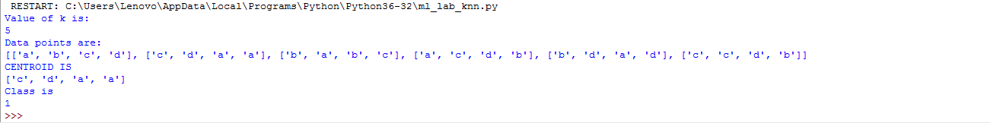

RESTART: C:\Users\Lenovo\AppData\Local\Programs\Python\Python36-32\ml_lab_knn.py

Value of k is:

5

Data points are:

[['a', 'b', 'c', 'd'], ['c', 'd', 'a', 'a'], ['b', 'a', 'b', 'c'], ['a', 'c', 'd', 'b'], ['b', 'd', 'a', 'd'], ['c', 'c', 'd', 'b']]

CENTROID IS

['c', 'd', 'a', 'a']

Class is

1

>>>